**WEB DEVELOPMENT PROJECT**

**LPU Website Copy**

Under the guidance of my favourite teacher 😊

**MR. Arun Kudiyal**

* Submitted By

**Aditya Chaudhary**

**12217276**

**KOC33**

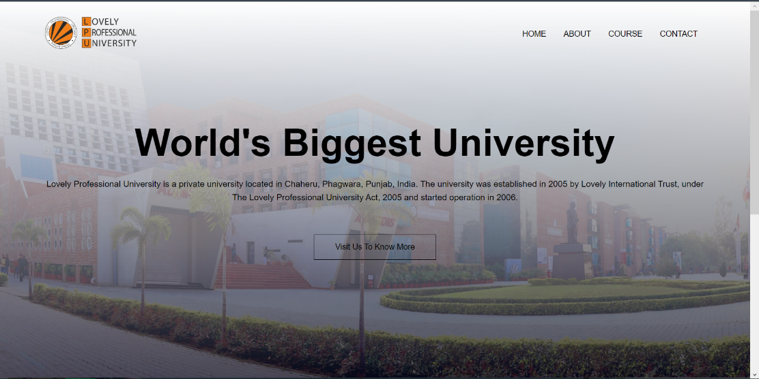

**TECHNOLOGIES USED**

**HTML-**The Hyper-Text Markup Language is the standard markup language for documents designed to be displayed in a web browser. HTML describes the structure of web page semantically and originally included cues for the appearance of the document.

**CSS-** Cascading is a style sheet language used for describing the presentation of a document written in a markup language such as HTML or XML. CSS is a cornerstone technology of World wide web, alongside HTML and JavaScript. CSS is the language for describing the presentation of Web pages, including colours, layout, and fonts.

**About Project**

**Copy of LPU Web Site**

* This website is copy of LPU main site but not responsive which I will be doing in near future.
* I have made this project using my skills of HTML, CSS.

**THE UPPER PART OF MY WEBSITE-**

**HTML CODE-**

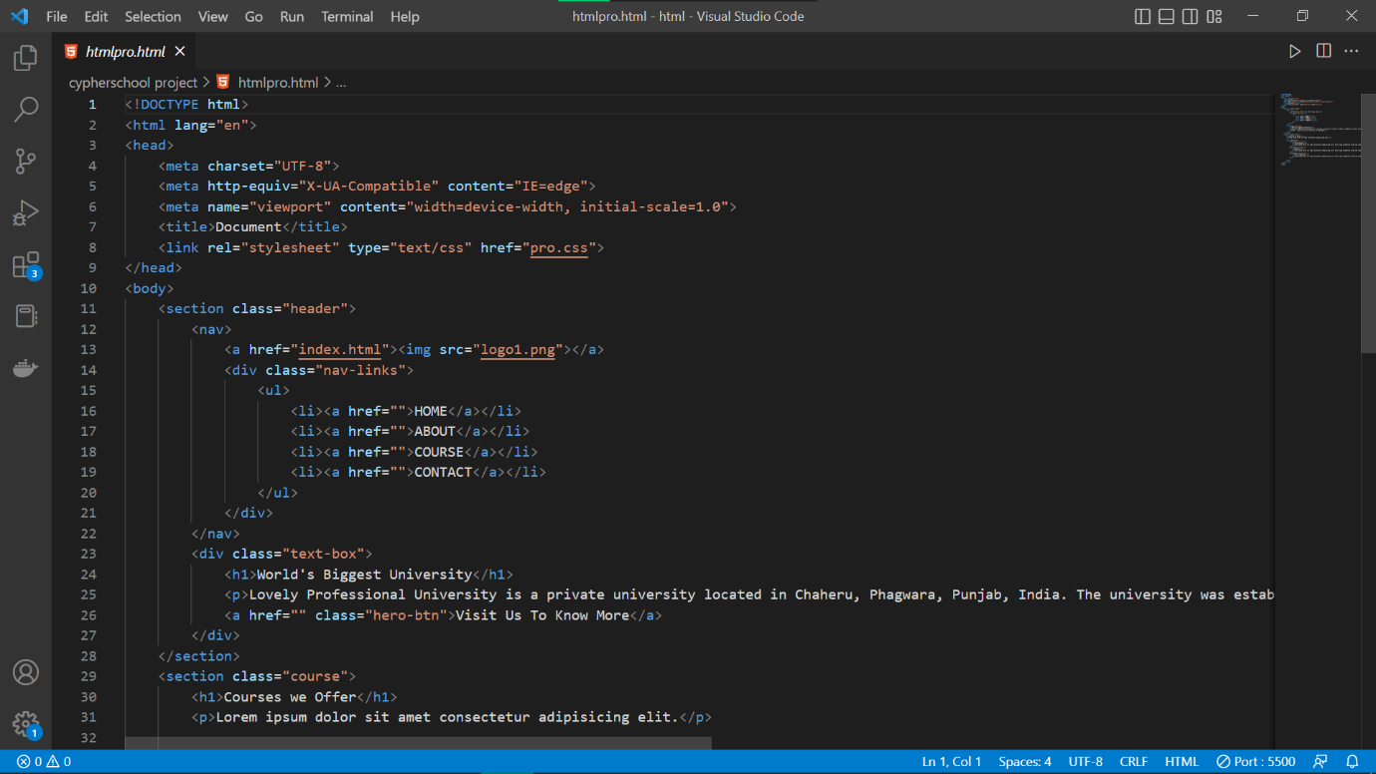

I tried to keep the header part as simple as possible. This will help the user to interact and navigate on website easily. I put a simple logo of LPU. All the header part is not clickable.

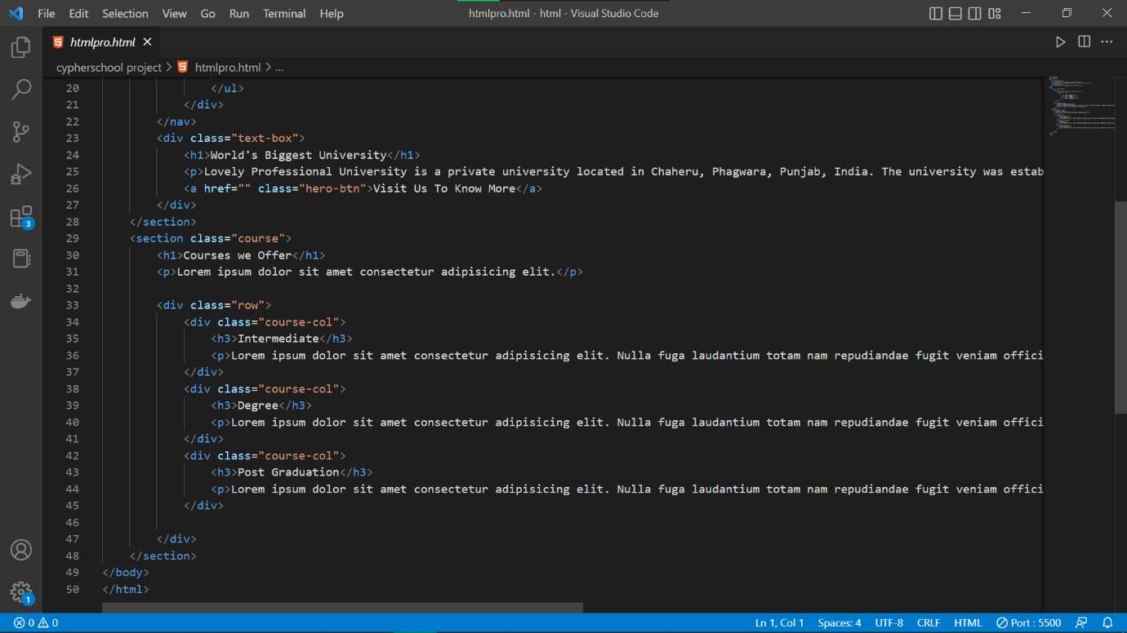

**CODE CSS-**

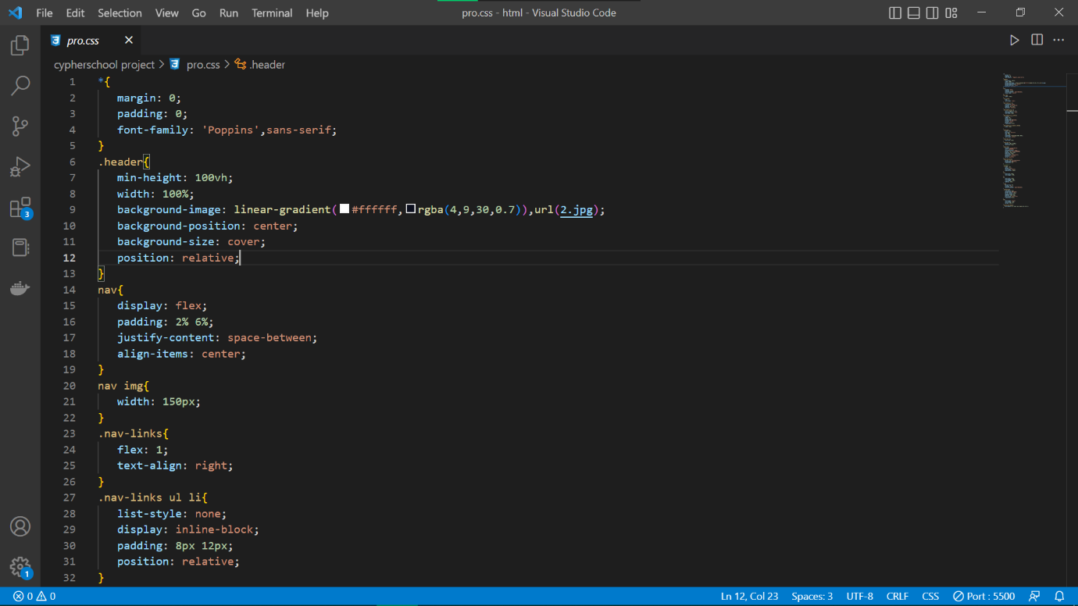

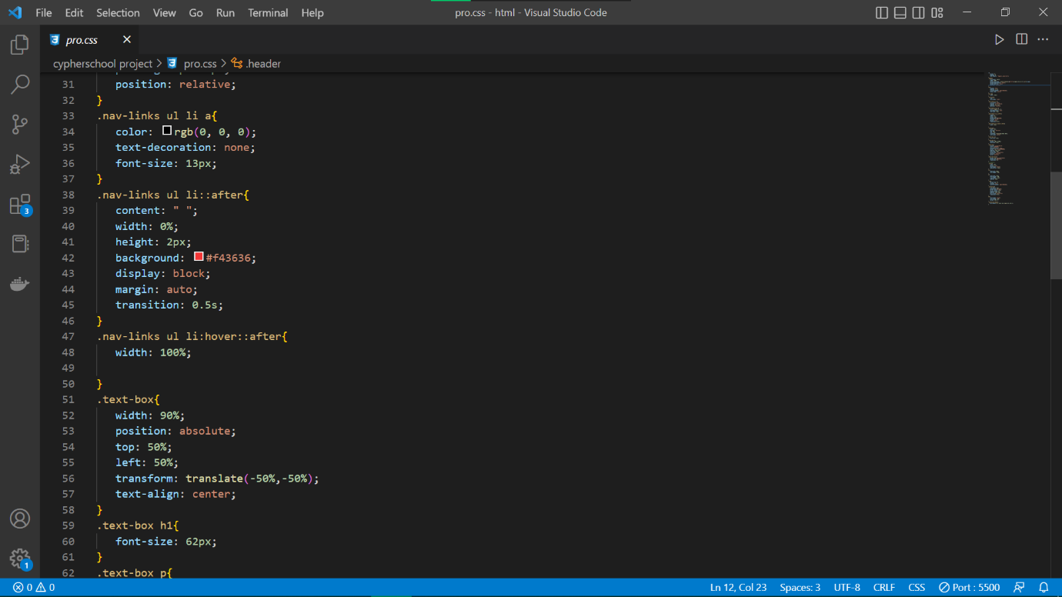

This CSS part contain all the styling of my site. I have done various styling for different parts of my code. I used a lot of classes and less id’s in my code . My

Code is basic code which is easy to understand by any one who have basic knowledge to it also.

